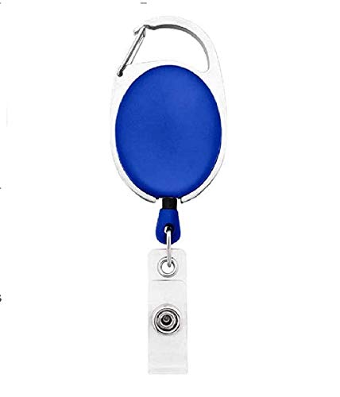

EMPLOYEE CARD

***EMP1256***

|  |  |
| --- | --- |
| **MICHAEL WILLIAMS** | PHOTO |
| **Human resource** |
| **Joining:02/12/2022** |
| **Blood Group:O+VE** |
| **Phone:8046158021** |

www.companywebsite.com